
Import Product Data from csv-file

© Eagle Datamation International Pty Ltd
• Level 2, 184 Bourke Road Alexandria NSW Australia
• Phone 61 2 9025 1100 • Fax 61 2 9025 1199 • training@edi.com.au

Table of Contents

1 Introduction 1
1.1 Important Remarks 1
1.2 Importing Product Data 1
2 File Specification 4
2.1 Generic Attributes of csv-Data Import Files 4
2.2 File Specification 4

Introduction

ediEnterprise has the capability to import Product data from a csv-file. This document describes the standard file format for import of Product Master File data.
The data can be imported into ediEnterprise using the option Config → Customs Files → Products → Export/Import → Import From Excel (.csv).

Important Remarks

It is essential that you strictly follow the file specification described in this document. If you would like to import Product data in a different file format, customer-specific programming will be necessary. This would be chargeable programming and require a quotation.

- The system will not import Product Codes that do not have a valid Owner or Supplier Code, or that are linked to a Classification Code that does not exist in ediEnterprise.
At the end of the data import the system will display all Product Codes that have been excluded from the data import for this reason. The operator may print the list.
- The system matches Products by Product Code, Owner Code and Supplier Code in order to determine whether or not a Product is a duplicate. The same Product Code can only exist once for the same Owner/Supplier code combination.
- The system allows you to update all Product information provided in the file with the exception of Product Code, Owner Code and Supplier Code. Changing any of these values would create a new Product.
- If you update the Import Classification Code, the system automatically erases the data in the fields “Add Info”, “Preference”, “Treatment Code” and “Instrument Type/Code”. The old values are stored as a Note on the Notes tab for future reference.

Importing Product Data

Select Config → Customs Files → Product → Export/Import → Import From Excel (.csv) to import Product data from a csv-file as per file specification below.
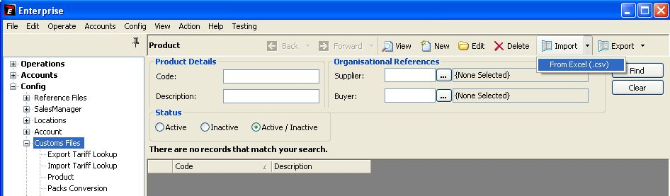

The system will prompt you:
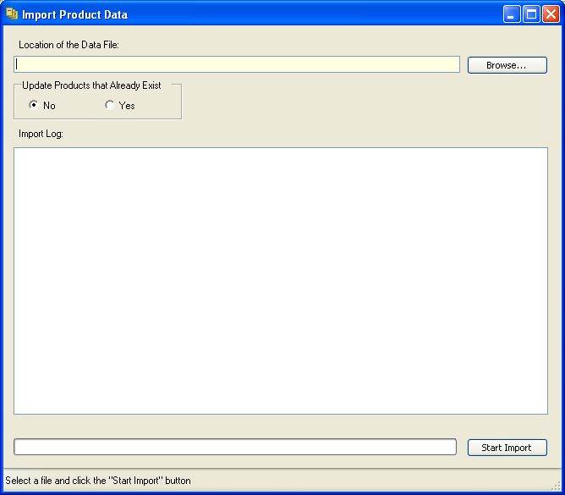

Option | Description
Location of the Data File | Enter the data-directory and file name.
Update Products that Already Exist:
No | If ticked, Product Codes that already exist for the same Owner and Supplier code combination will be excluded from the data import. All other Products will be imported.
Yes | If ticked, Product Codes that already exist for the same Owner and Supplier code combination will be updated, and new Products will be imported.  Please carefully read the notes under chapter 1.1 Important Remarks to understand the implications of a Product data update.

Press the [Start Import] button to import the Product data.

System Prompt, if you choose to Update Products:
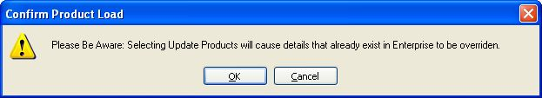

Example for Notes created, if the Import Classification code is updated:
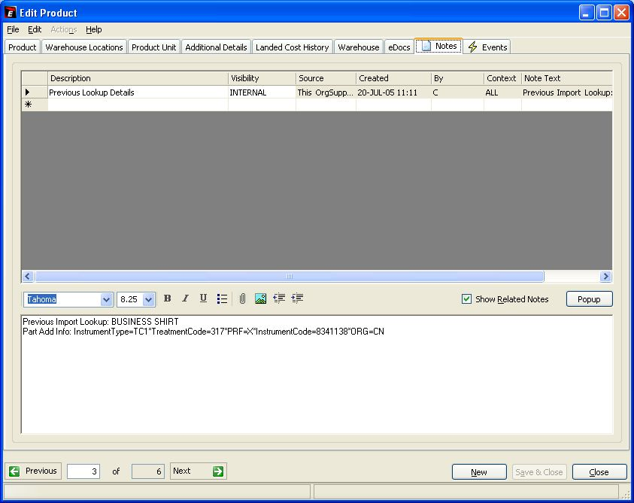

File Specification

Generic Attributes of csv-Data Import Files

The following applies to the standard ediEnterprise data import files in csv-file format:
- The file format is csv-file.
- The first line of the file must be the header line. It must contain the headers in exactly the same spelling as per file specification below. Otherwise the data will not be imported.
- It is essential that you provide all columns in the order as listed in the file specification. Do not add any additional columns or omit any columns. Otherwise the data will not import.
- Leave non-mandatory fields blank, if you cannot provide the data.
- Date fields are 8 characters in the form YYYYMMDD. No separators are allowed.
- Boolean fields are character “Y” = True or character “N” = False.
A blank boolean field is interpreted as “N”.
The system validates the header of each column to determine whether the file structure matches the standard. If the number of columns differs or the column headers are spelt differently, the data will not import.

If you haven’t already received a sample file, you are welcome to contact edi and request one.

File Specification
Legend:
Col Column
Type A = alphanumeric
N = numberic
B = Boolean
M = mandatory
C = Conditional

Col | Header | Type | M | Remarks
 | CODE | 30 A | M | Product Number.  The same Product Number may occur multiple times provided it is linked to different Suppliers or Importers.
 | DESCRIPTION | 80 A | M | Product Description
 | CLASSIFICATION | 35 A |  | Australian Sites:  Option 1: If this Product is exported, provide the Import Classification code. This code needs to match the Export Classification code set up in ediEnterprise → Config → Customs Files → Import Classification.  Option 2: Provide the Export Tariff. The system will try to find a matching Export Classification code; otherwise it will create a new Export Classification using this Tariff.  Other countries:  Option 1: Provide the Classification code. This code needs to match the Classification code set up in ediEnterprise → Config → Customs Files → Classification.  Option 2: Provide the Tariff. The system will try to find a matching Classification code; otherwise it will create a new Classification using this Tariff.
 | ADDITIONAL_CLASSIFICATION | 35 A |  | Alternative Classification Code.  Australian Sites:  Option 1: If this Product is imported, provide the Export Classification code. This code needs to match the Import Classification code set up in ediEnterprise → Config → Customs Files → Export Classification.  Option 2: Provide the Import Tariff. The system will try to find a matching Import Classification code; otherwise it will create a new Import Classification using this Tariff.  Other countries:  Not applicable, leave blank.
 | SUPPLIER | 12 A | C  *) | Supplier code.  This code needs to match the Organisation code set up in ediEnterprise → Config → Organisation.  *) The Product will only import, if a valid Owner or Supplier Code is provided in the file.
 | IMPORTER | 12 A | C  *) | Owner/Importer code.  This code needs to match the Organisation code set up in ediEnterprise → Config → Organisation.
 | QUANTITY_UNIT | 3 A |  | Stock/commercial unit of quantity
 | UNIT_WEIGHT | 6.3 N |  | Weight per unit.
 | WEIGHT_UNIT | 3 A |  | Weight Unit of Quantity.
 | UNIT_VOLUME | 6.3 N |  | Volume per unit.
 | VOLUME_UNIT | 3 A |  | Volume Unit of Quantity.
 | DIVISION | 15 A |  | Division data is captured for information and reporting purposes.
 | QTYINSTOCK | 7.2 N |  | Quantity in Stock

